1973 P337 FOR SALE (REAMS)

Have over $175,000.00 invested selling for $80,000.00. this is a no bullshit offer
And only interested in sincere inquires. Have all logs u.s. and german. I,m done

History:
Located in yuma Arizona, shade hanger #5
1973 skymaster/reams – p337
Avonics – complete ifr stack, all panel mounted ups/garmen
Autopilot 400a 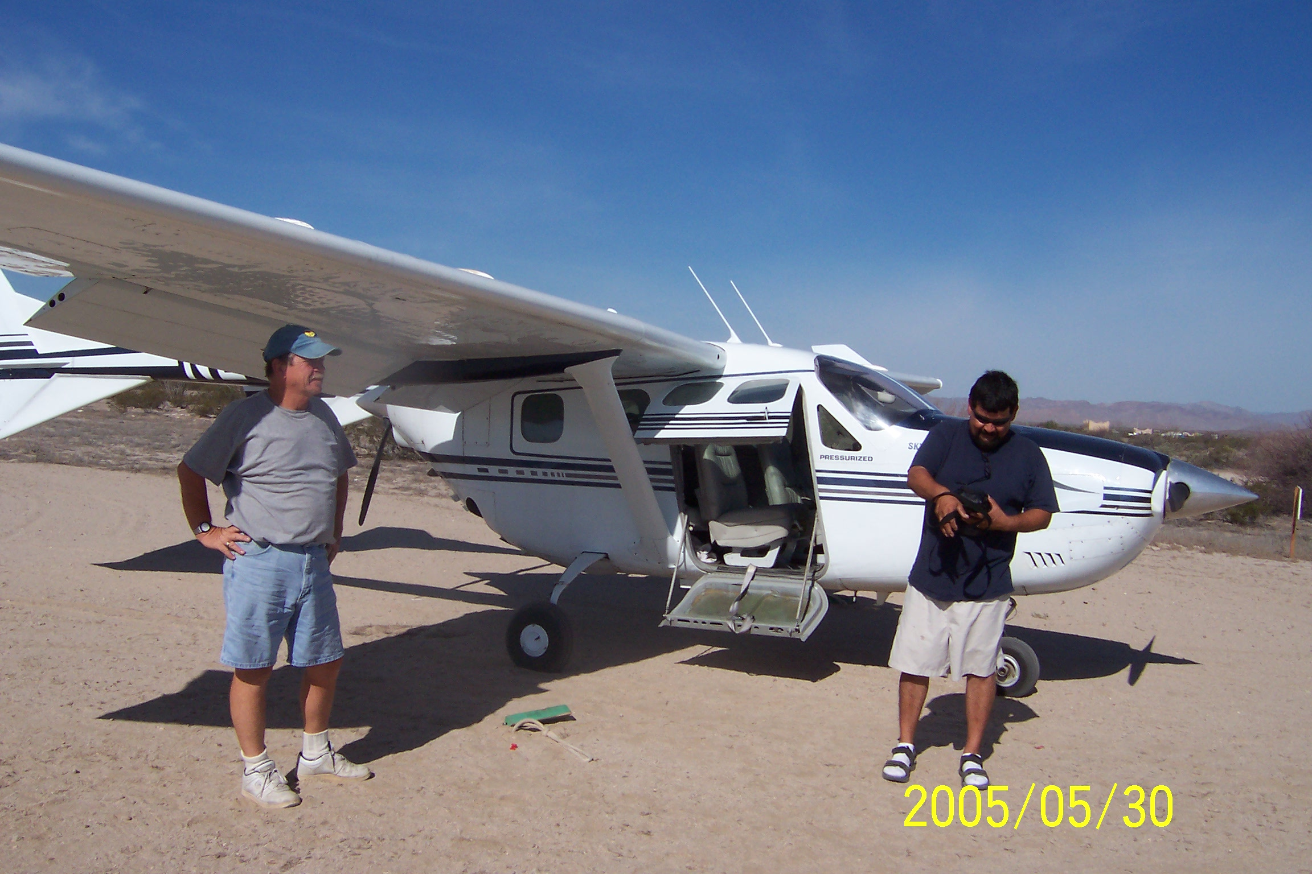coupled to vor/gps
jpi760 engine analyzer
Shadden fuel computer
Prop sync
Rosen sun shades
Interior is a 9 grey leather interior and wool rugs, new headliner and interior sides
Exterior is a 7 (been outside for three years) needs spot painting and a great wax job
Stol kit
Boom fairings top and bottom
Riley winglets
Riley intercoolers
Gear door mod
120v oil pan heaters
Four headsets

Just replaced all hyd hoses, overhauled hdy/elect pack.
Front prop 450.0 rear 0.0
Front and rear engines 450.0 – these are factory remans including All accessories.
New hoses with red heat covering, baffling is perfect
Total time on ac – 1,750.0

Minor gear up (front nose stayed up, rear did not lock down – hyd hose broke and pumped all the hyd fluid out. Needs two landing gear strut doors and some minor
belly skin repair (about one square foot). Also could use a new battery and box.
That is about the extent of repairs except for an annual. I estimate that between 10
And 15k and it would be in perfect shape, add another 10k for paint and you have a
show piece. If you are very serious you can contact me. Someone may consider
parting it out, by my calculations you would make at least 50% on you money. Hate
to see that as it’s too good of a aircraft.

Rick bell
011 52 686 577 6185 mex,
“alsharpton@earthlink.net

