The Ultimate SKYMASTER
300+ mph, 3000 fpm climb (700 hp, Air Conditioned, Speed Brakes, up to 2500 mile range)

Order one now for your traveling convenience. owen.bell@juno.com
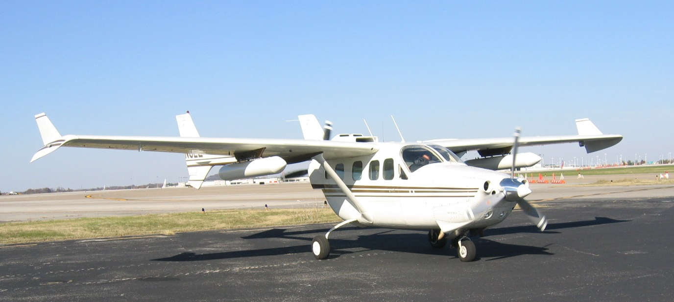
Mods & Parts  For All  Skymasters | -Air Conditioning  -Rear Engine Cooling Mod  -2500 Mile Fuel Range  -Engine Conversions  -Increase useful load (GWI)  -Medium Tail Boom Fairings | -Large Tail Boom Fairings ----Low Oil Pressure warning  -Winglets (gain 10-20 mph)  -Long Range aux fuel tanks ---Up to 2500 lb useful load  -Speed Brakes | -3 blade propellers  -Replica O-2A  -Huge Parts Inventory  -Skymaster on floats  -Fire detection system  -Wing mirrors | -STOL  -Performance Mods  - Cowl Flap Motors  -Mechanical Cowl Flaps  -Wing stall fences  - Etc. Etc.
Initial and Recurrent Skymaster Training – Conventional Twin Engine Training. FINANCING AVAILABLE
SKYMASTER SERVICES: Annual inspections flat rated (includes balancing both props) Full service facility for maintenance, repairs, modifications, etc. Call us for all of your Skymaster needs. 615-585-7765 or 615-865-1802 owen.bell@juno.com (www.aviationenterprises.us)

